JWT Authentication & Authorization with Spring Security | Step-by-step tutorial

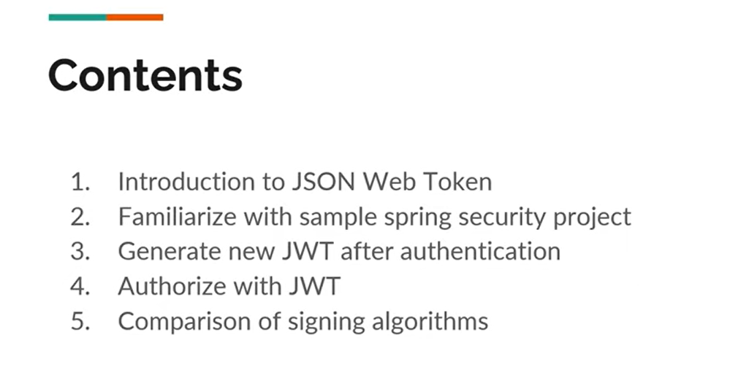

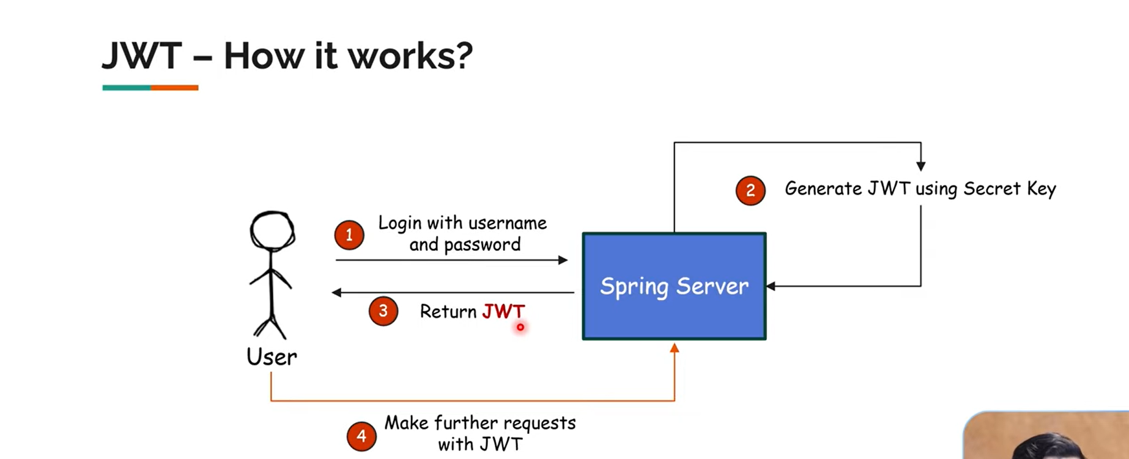1. User Logs In With Username & Password
- The client (user) sends their username and password to the Spring server via an HTTP request (usually a POST request to a /login or /authenticate endpoint).
- The server checks the credentials (e.g., queries the database) to verify that the user exists and the password is correct.

2. Server Generates JWT Using Secret Key
- If the credentials are valid, the server creates a JWT.
- The JWT includes:
  - Header: Specifies the signing algorithm (e.g., HS256).
  - Payload: Contains user data (e.g., username, roles, expiration time).
  - Signature: Created by signing the header + payload with the secret key.

3. Server Returns the JWT to the User
- The server responds with a JSON containing the JWT (e.g., {"token": "<JWT_VALUE>"}) or sets it in a HTTP-only cookie (depending on your setup).
- The user stores this token on the client side (e.g., localStorage, sessionStorage, or an in-memory variable).

4. User Makes Further Requests With the JWT
- For subsequent requests to protected endpoints, the user attaches the JWT in the Authorization header:
makefile
CopyEdit
Authorization: Bearer <JWT_VALUE>
- The server verifies:
  - Signature: Checks if the token was signed with the correct secret key (no tampering).
  - Expiration: Ensures the token is still valid (not expired).
  - Claims: Confirms the user’s identity and roles.
- If valid, the server grants access to the requested resource. If invalid or expired, the request is denied (401 Unauthorized), and the user may need to log in again.

Why This Flow Is Useful
- Stateless: No session data is stored on the server. Each request carries its own authentication data (the JWT).
- Scalable: Since the server doesn’t maintain session state, adding more servers or microservices is easier.
- Flexible: JWT can be used across different domains, APIs, or microservices without needing session replication.

Key Points to Remember
- Keep the Secret Key Safe: If anyone obtains the secret key, they can forge valid tokens.
- Short Token Lifespan: Tokens typically expire within minutes or hours. This limits exposure if a token is leaked.
- Refresh Tokens: Often used to get new access tokens without forcing the user to re-login.
- Use HTTPS: Always send JWTs over secure connections to prevent token theft.

That’s it! The diagram essentially shows:
- Login → 2. Generate JWT → 3. Send JWT to User → 4. Use JWT on Subsequent Requests.

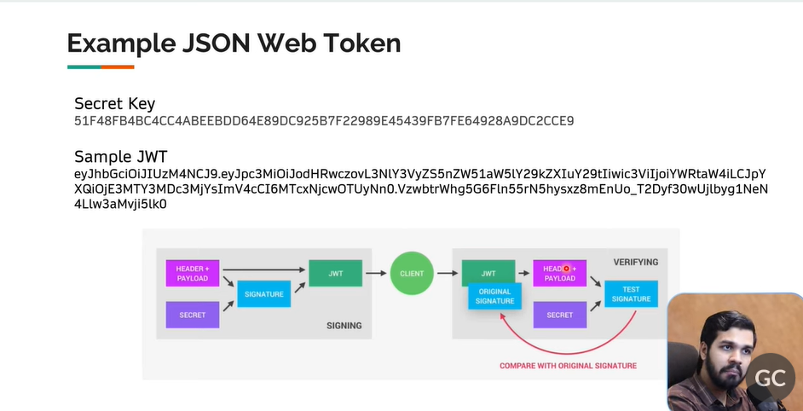
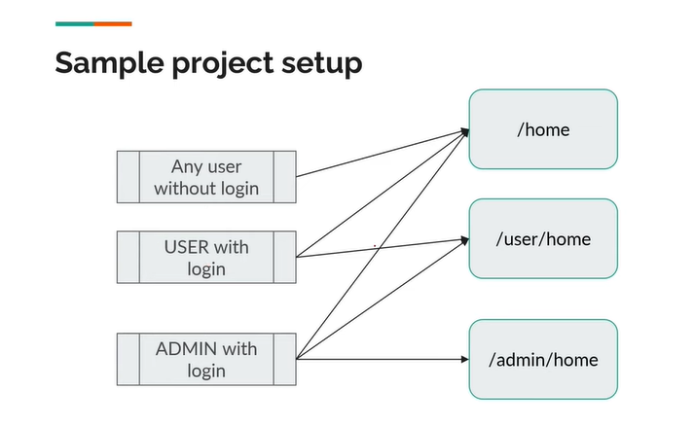
Entity
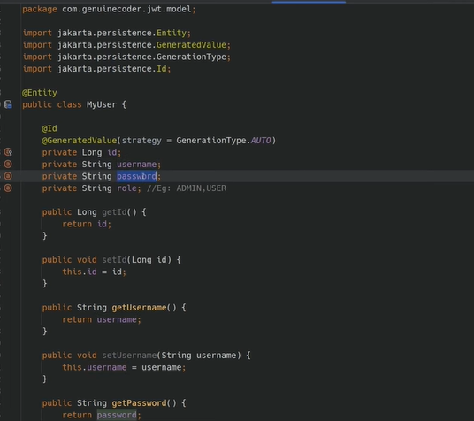

UserDetailsServiceImplemenetation
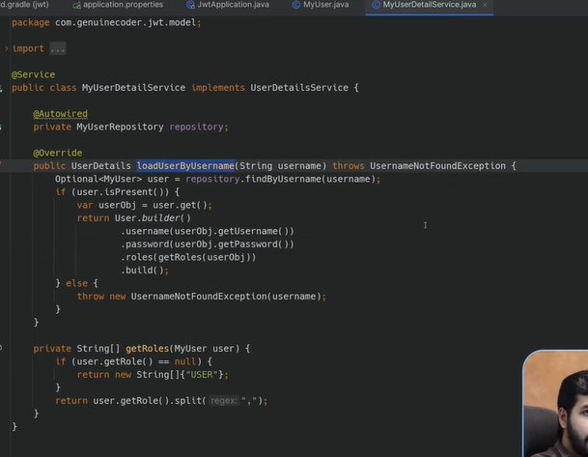

Controller
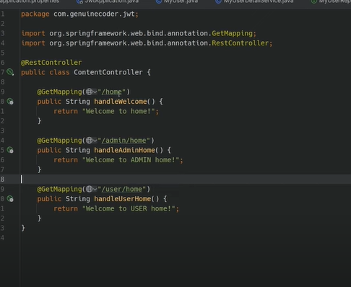

AndJpaRepostory
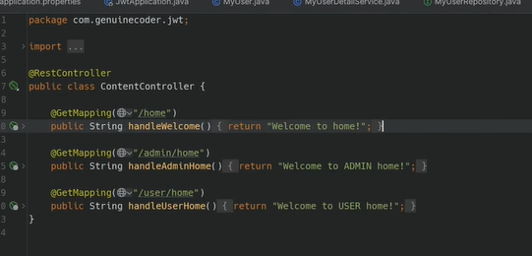
SecurityConfig
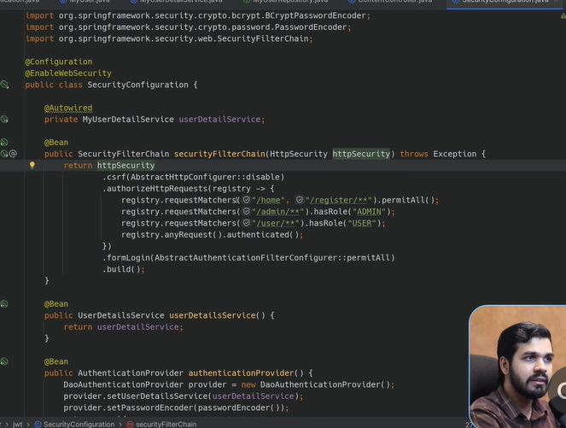

Controller for Registration
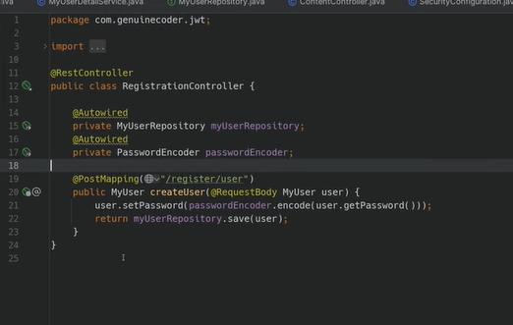

Dependency for JWT API
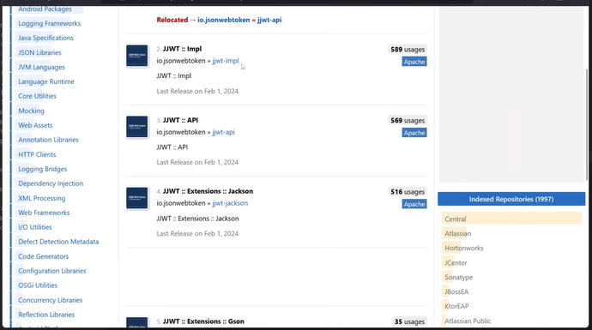
To generate a SecureSecretKey
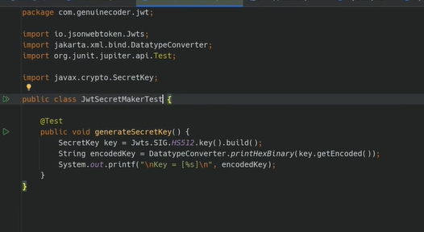
Will be using that key to generate a token and we will be generating it for suers so
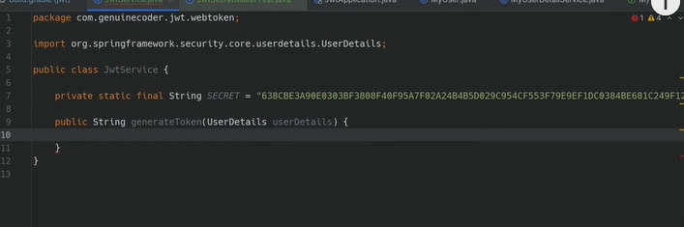

Subject will be for whom we are generating the token
For issued and expiration date will use Date from java.util
Also will require a secret key which we need to generate and it will be in Byte[]Array form

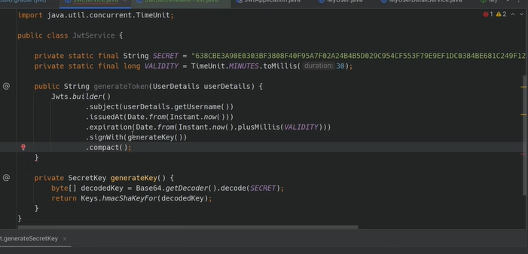
Claims for PayLoad are Essential
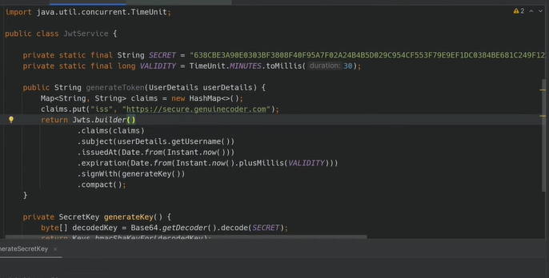

JWT Claims & Payload – A Complete Explanation
In JSON Web Tokens (JWT), the Payload is the second part of the token (after the header), and it contains a set of claims. These claims are basically statements about an entity (often the user) and additional metadata. Let’s break down the concept of claims and how they relate to the payload in a JWT.

1. JWT Structure Recap
A JWT is typically represented as three Base64Url-encoded parts separated by dots (.):
css
CopyEdit
Header.Payload.Signature
- Header: Contains metadata about the token (e.g., signing algorithm, token type).
- Payload: Contains claims about the user or other data.
- Signature: Verifies the token’s integrity using the header, payload, and a secret key.

2. What Are Claims?
Claims are key-value pairs that convey information about the user or the token. They are stored in the payload section of the JWT. Claims can be standard (registered) or custom.

2.1 Registered (Standard) Claims
The JWT specification defines several registered claims, such as:
- iss (Issuer): Identifies who issued the token.
- sub (Subject): Identifies the principal (usually the user) to which the token refers.
- aud (Audience): Identifies the recipients for which the token is intended.
- exp (Expiration Time): The time after which the token must not be accepted.
- nbf (Not Before): The time before which the token must not be accepted.
- iat (Issued At): The time at which the token was issued.
- jti (JWT ID): A unique identifier for the token.
Note: You don’t have to use all of these, but they are commonly used for best practices (especially exp, iat, and sub).

2.2 Custom Claims
You can add custom claims to store additional information relevant to your application. Common examples include:
- role or roles: The user’s role(s) (e.g., ADMIN, USER).
- email: The user’s email address.
- permissions: A list of actions the user can perform.
- organization: The user’s organization or tenant.
Important: Use a namespace or prefix to avoid conflicts with standard claims (e.g., org.example.role).

3. How Claims Are Encoded in the Payload
The payload is a JSON object containing all claims. For example:
json
CopyEdit
{
"sub": "user123",
"role": "ADMIN",
"exp": 1712563200,
"iat": 1712559600
}
When creating a JWT, this JSON payload is Base64Url-encoded (i.e., safe for URLs) and placed between the header and the signature.

4. Example of a Complete JWT
plaintext
CopyEdit
HEADER:
{
"alg": "HS256",
"typ": "JWT"
}

PAYLOAD (claims):
{
"sub": "user123",
"role": "ADMIN",
"exp": 1712563200,
"iat": 1712559600
}

SIGNATURE:
HMACSHA256(
base64UrlEncode(header) + "." + base64UrlEncode(payload),
secret_key
)
Putting it all together (in Base64Url-encoded form) might look like this:
CopyEdit
eyJhbGciOiJIUzI1NiIsInR5cCI6IkpXVCJ9.
eyJzdWIiOiJ1c2VyMTIzIiwicm9sZSI6IkFETUlOIiwiZXhwIjoxNzEyNTYzMjAwLCJpYXQiOjE3MTI1NTk2MDB9.
Q4zFh1lHUfzElq9FUR6jTrggkBB3nRqY3T8X8yg2haM

5. Validating Claims
When a server validates a JWT, it typically checks:
- Signature: Ensures the token wasn’t tampered with.
- Expiration (exp): Rejects tokens that are expired.
- Not Before (nbf): Ensures the token is valid after a certain time.
- Subject (sub): The user or entity is correct.
- Audience (aud): The token is intended for this server.
If all checks pass, the server trusts the claims inside the token and can make authorization decisions (e.g., check if role == ADMIN).

6. Common Use Cases for Claims
- Authentication: Storing a sub (subject) claim that identifies the user ID.
- Authorization: Storing user roles or permissions in custom claims (e.g., role, permissions).
- Multi-Tenant Apps: Including an organization or tenant_id claim.
- Session Tracking: Using iat (issued at) to handle logout logic or token invalidation windows.

7. Best Practices
- Use Short-Lived Tokens:
  - Set exp (expiration) to a short time (minutes or hours) to reduce the risk if the token is stolen.
- Refresh Tokens:
  - If you need long-lived sessions, use refresh tokens (stored securely) to obtain new short-lived access tokens.
- Avoid Storing Sensitive Data:
  - JWTs can be decoded by anyone. Never store passwords or private user data in claims.
- Use HTTPS:
  - Always transmit tokens over secure channels to prevent interception.
- Sign with a Strong Secret Key:
  - For HS256, use a 256-bit secret key. Or use asymmetric keys (e.g., RS256) for even stronger security.

Summary
- Claims are key-value pairs that store user-related data (standard or custom).
- Payload is the middle part of the JWT, containing these claims in JSON form.
- Registered Claims (like sub, exp, iat) are standard across JWT implementations.
- Custom Claims let you store app-specific data (roles, permissions, etc.).
- Security: Always validate the token’s signature, expiration, and claims before trusting the data.
That’s how claims and the payload work together in a JWT to securely transmit user information for authentication and authorization in stateless systems.
o3-mini

RealTime Example Explanation
Here’s a real-time example of how JWT claims and payload might be used in a Food Delivery application. This scenario will illustrate how standard and custom claims can secure different parts of your system.

Scenario: Food Delivery App
Imagine you have a Food Delivery App with:
- Customers who place orders.
- Delivery Personnel who deliver orders.
- Restaurant Managers who manage menus.

1. Customer Logs In
- Customer enters username and password into the Food Delivery app.
- The app sends these credentials to your Spring Boot server (e.g., POST /login).
- The server verifies the username/password against the database.

2. Server Generates JWT
- Once the credentials are valid, the server creates a JWT with:
  - Standard Claims:
    - sub (subject): The user’s unique ID, say user_12345.
    - iat (issued at): Timestamp of when the token was issued.
    - exp (expiration): The time when the token will expire (e.g., 1 hour from now).
  - Custom Claims:
    - role: For a customer, it might be "CUSTOMER".
    - preferred_restaurant: Maybe the user’s favorite restaurant ID.
    - delivery_radius: How far they can receive deliveries (useful if needed).
- The server signs the token using a secret key.
Example payload (in JSON) before Base64Url-encoding:
json
CopyEdit
{
"sub": "user_12345",
"iat": 1676483762,
"exp": 1676487362,
"role": "CUSTOMER",
"preferred_restaurant": "rest_987",
"delivery_radius": 5
}
The final JWT (simplified) might look like this once encoded and signed:
nginx
CopyEdit
eyJhbGciOiJIUzI1NiIsInR5cCI6IkpXVCJ9
.eyJzdWIiOiJ1c2VyXzEyMzQ1IiwiaWF0IjoxNjc2NDgzNzYyLCJleHAiOjE2NzY0ODczNjIsInJvbGUiOiJDVVNUT01FUiIsInByZWZlcnJlZF9yZXN0YXVyYW50IjoicmVzdF85ODciLCJkZWxpdmVyeV9yYWRpdXMiOjV9
.Q9nEH-nNu9v3NLSiZKZet8bAmS4qYnB1aS0udt16e7g
- The server returns the token to the client (e.g., as JSON or in a cookie).

3. Customer Places an Order (Subsequent Requests)
- The customer wants to place an order at /orders.
- The Food Delivery app includes the JWT in the Authorization header:
makefile
CopyEdit
Authorization: Bearer <JWT_TOKEN>
- The Spring Boot server receives the request, parses the JWT, and checks:
  - Signature: Ensures the token is from a trusted source.
  - Expiration (exp): Ensures the token isn’t expired.
  - sub: Identifies which user is placing the order (user_12345).
  - role: Confirms it’s a CUSTOMER (not a driver or manager).
- If valid, the server processes the order.

4. Delivery Personnel Checks Orders
- A delivery person logs in and gets a JWT with:
  - sub: driver_67890
  - role: "DRIVER"
- When they request GET /orders/assigned, the server checks:
  - Is the user’s role DRIVER?
  - If yes, they can see the assigned orders.
  - If no, the request is denied (403 Forbidden).

5. Restaurant Manager Updates Menu
- A manager logs in and receives a JWT with:
  - sub: manager_1122
  - role: "MANAGER"
- The manager sends a request to POST /menu/update with the JWT in the header.
- The server checks:
  - role is "MANAGER".
  - If valid, allow the menu update.
  - If not, deny the request.

Why Claims Matter in Real-Time
- Authentication:
  - sub tells the server which user is making the request.
  - exp ensures the token is still valid.
- Authorization:
  - role indicates what level of access the user has (e.g., CUSTOMER, DRIVER, MANAGER).
  - The server can allow or deny specific endpoints based on role.
- Custom Business Logic:
  - preferred_restaurant might auto-populate a user’s favorite restaurant.
  - delivery_radius could be used to show the user which restaurants are available within 5 miles.

Summary of the Real-Time Flow
- User logs in with username/password.
- Server validates credentials and issues a JWT containing claims (role, sub, exp, etc.).
- User makes further requests to the server with the JWT in the Authorization header.
- The server checks the JWT for validity (signature, expiration) and role or other custom claims.
- If valid, the server executes the request; otherwise, it rejects it.

Takeaway
In a real-time system like a Food Delivery app, JWT claims help ensure each user (customer, driver, manager) can only perform the actions they’re authorized to do, without storing session state on the server. It’s a scalable, stateless, and secure approach to authentication and authorization.
o3-mini

For Authentication will require username and password
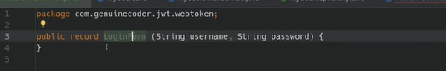
Record java pojo class is as simple as java class with getters and setters and constructors inbuilt
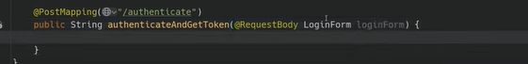
Will require a AuthenticationManager Bean as well which is Autowired
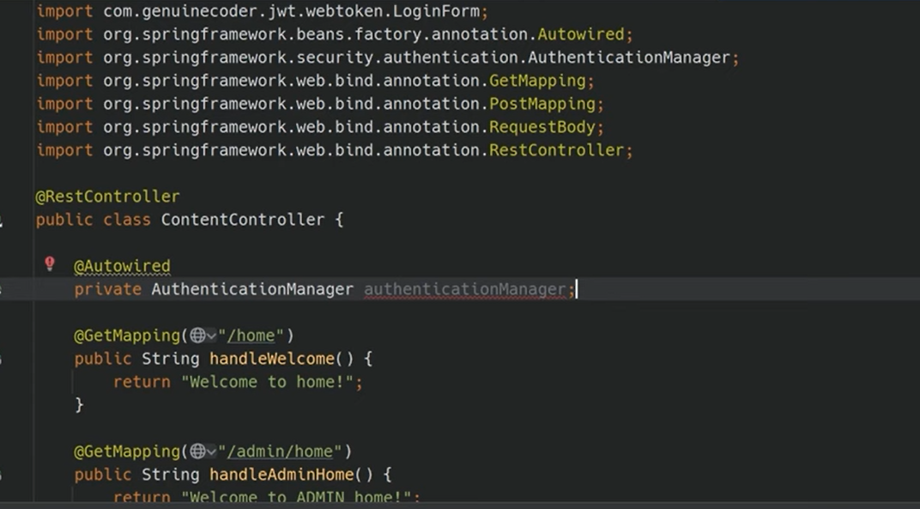

Will need to define this bean in securityconfig

Will use this to authenticate
Also we need to send jwt token so will autowire that also
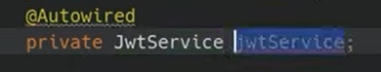
It should be @Service
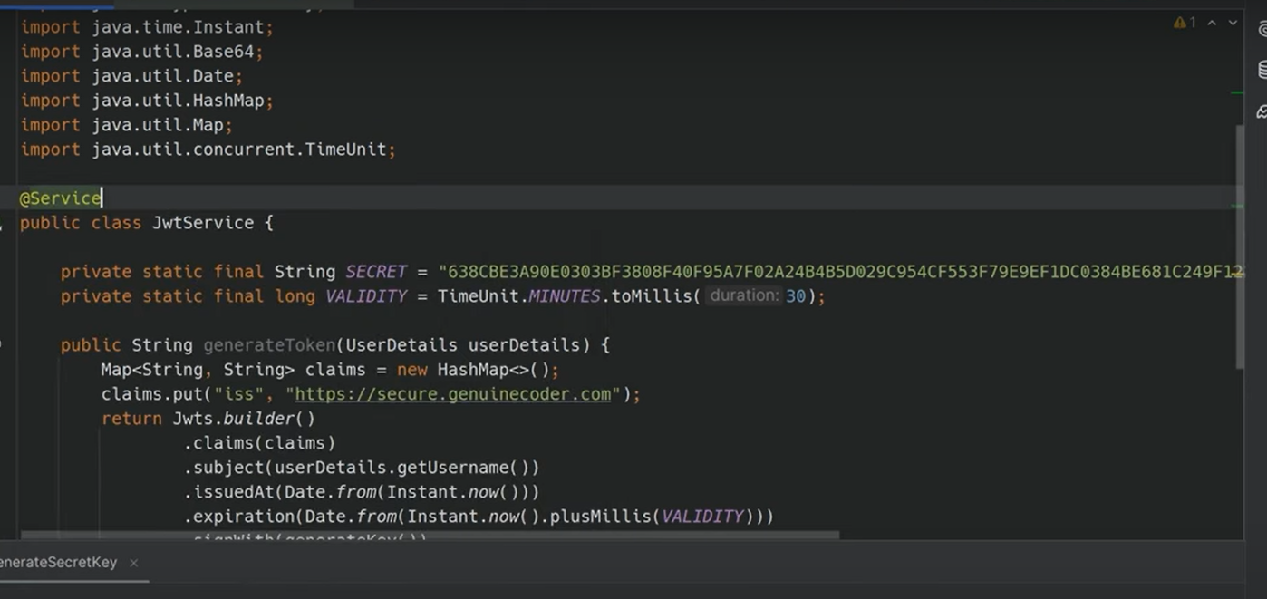

Will autowire this also
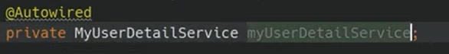
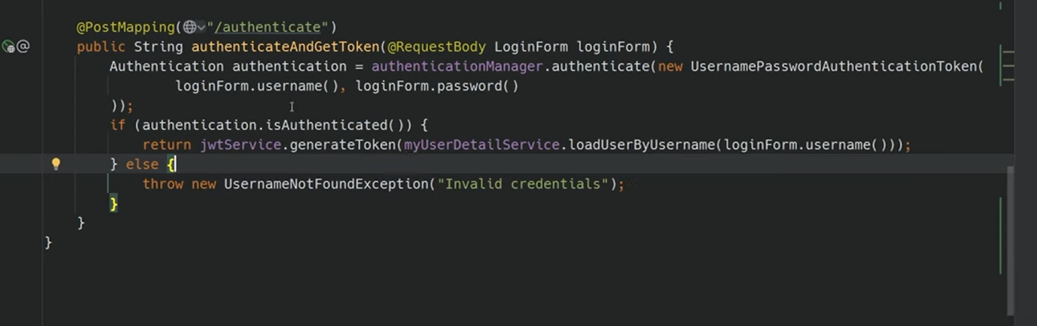
Permit this /authenticate in the configuration
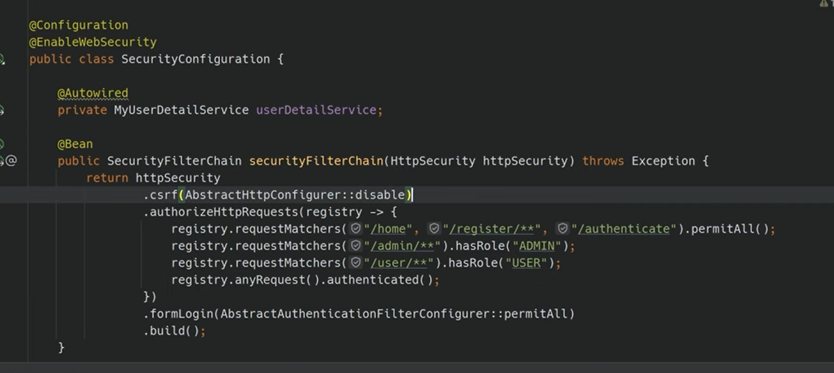
Thus we have finished Generating Token

Now we need to validate JWT and Give access
JWTAuthenticationFilter which will extends onceperfilterclass

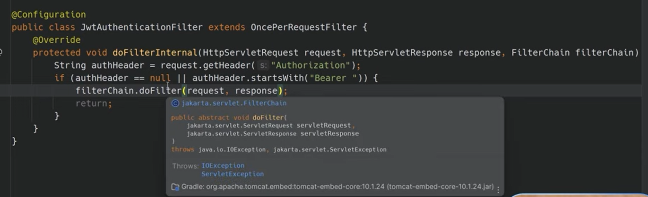
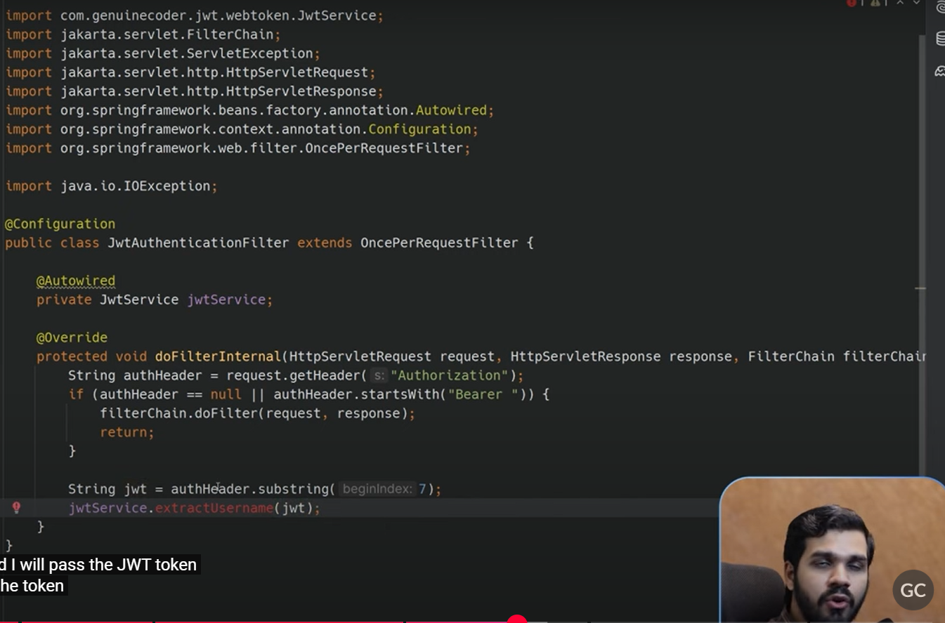
But we have to create this method in jwtservice to use it so lesgo
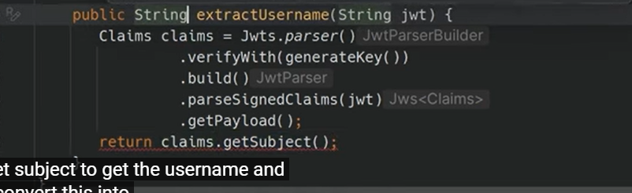
We will also need isTokenValid Method to check the JWT Token
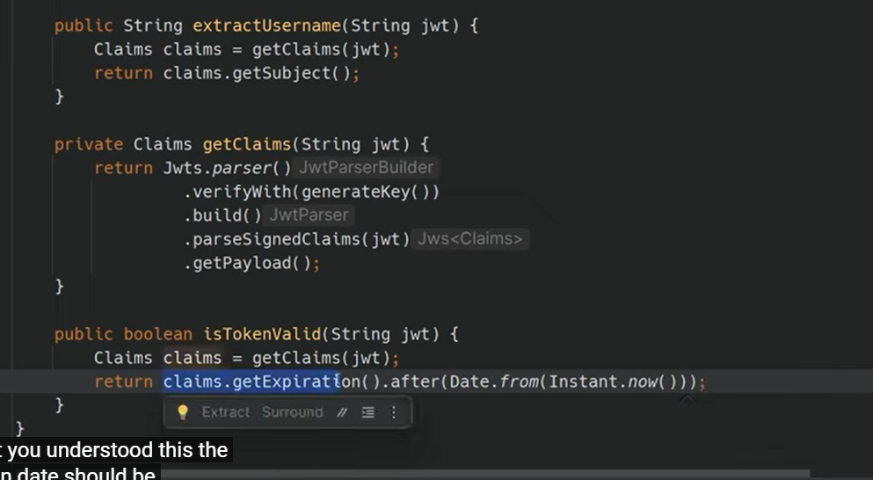
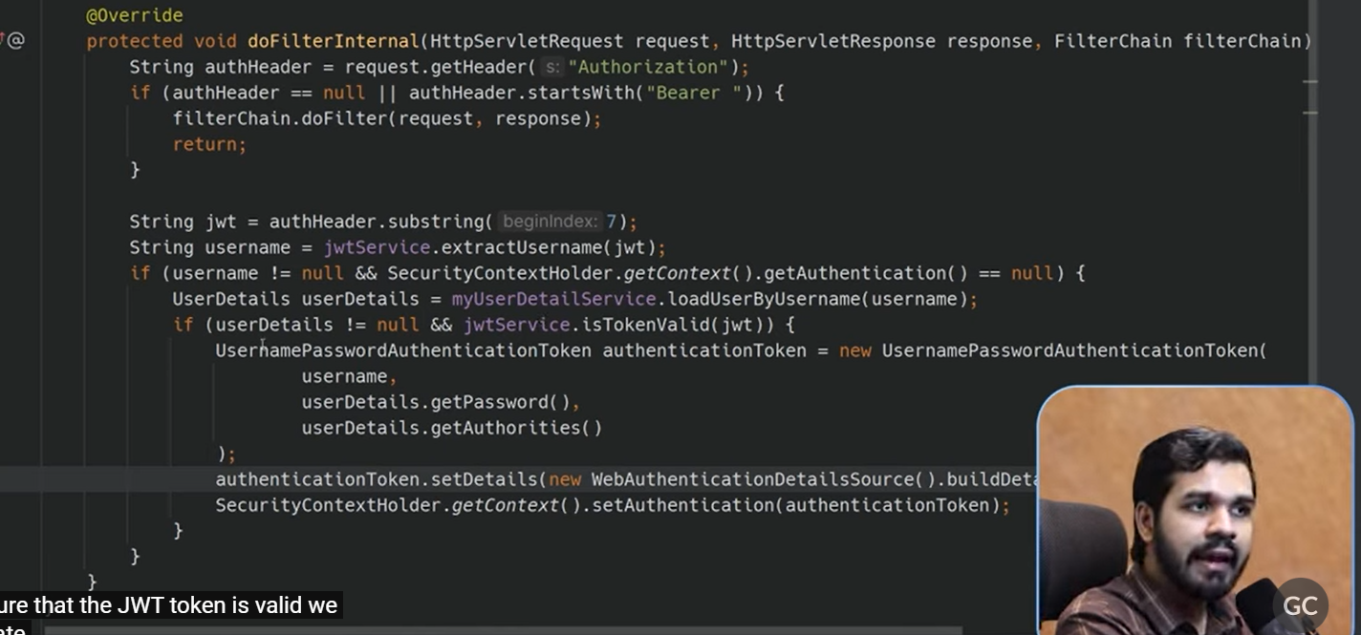
In SecurityConfig AUtofire this and add it to authenticate before
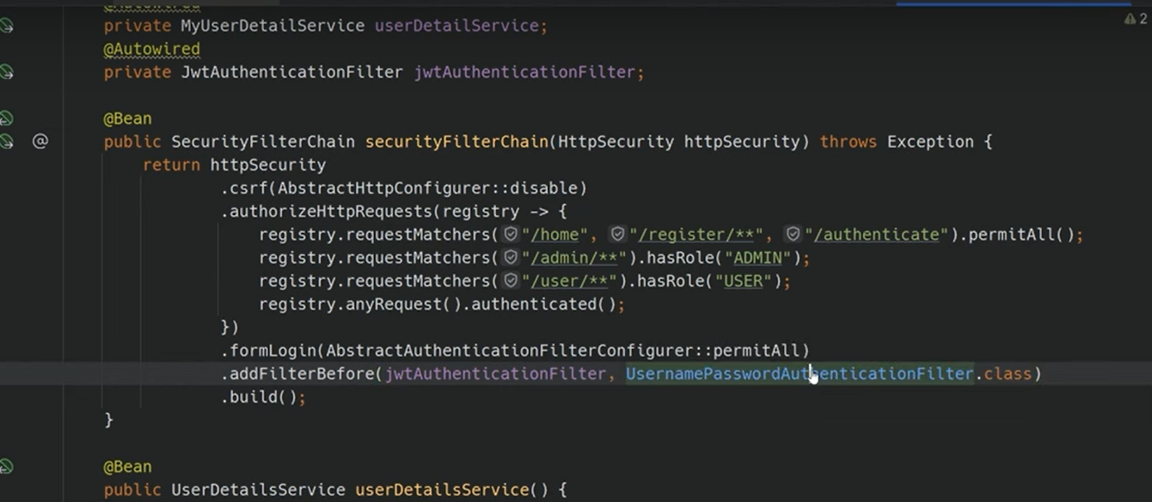
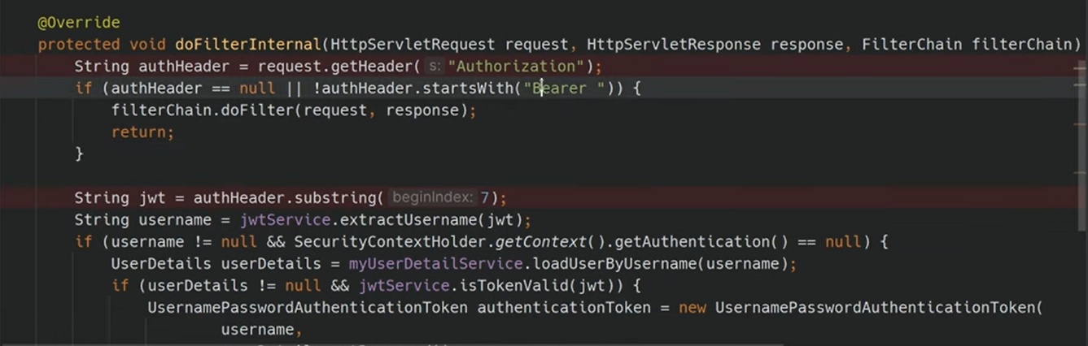
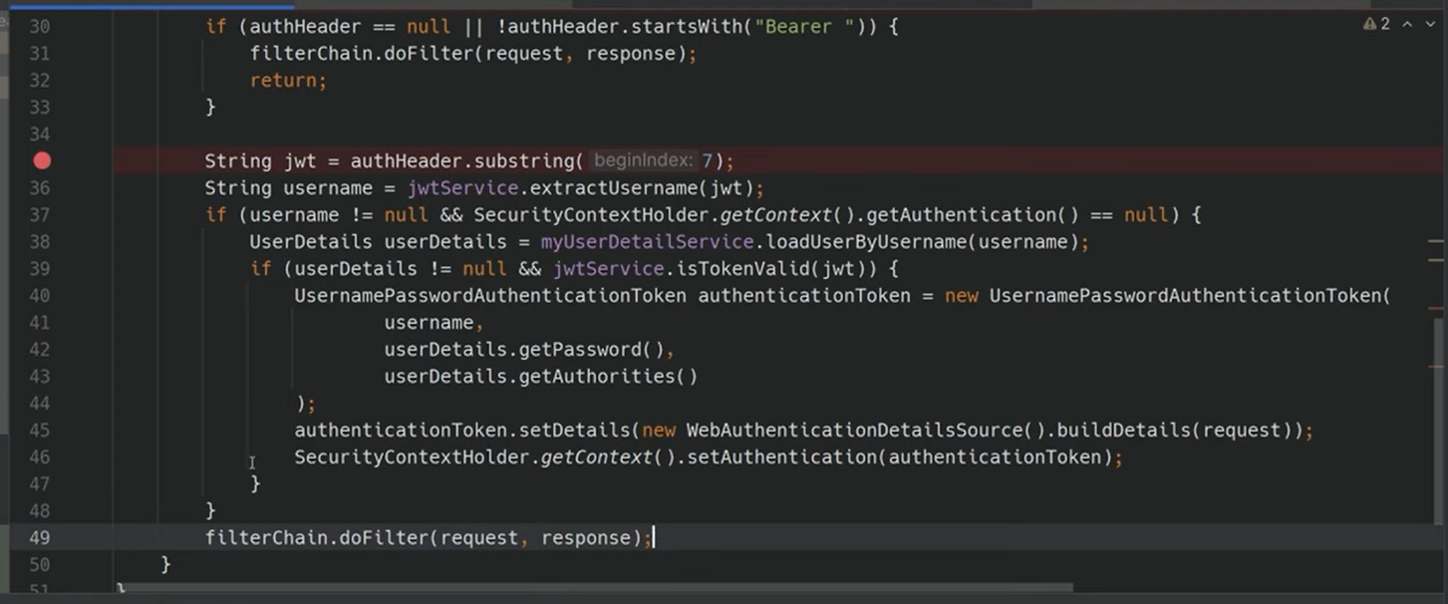
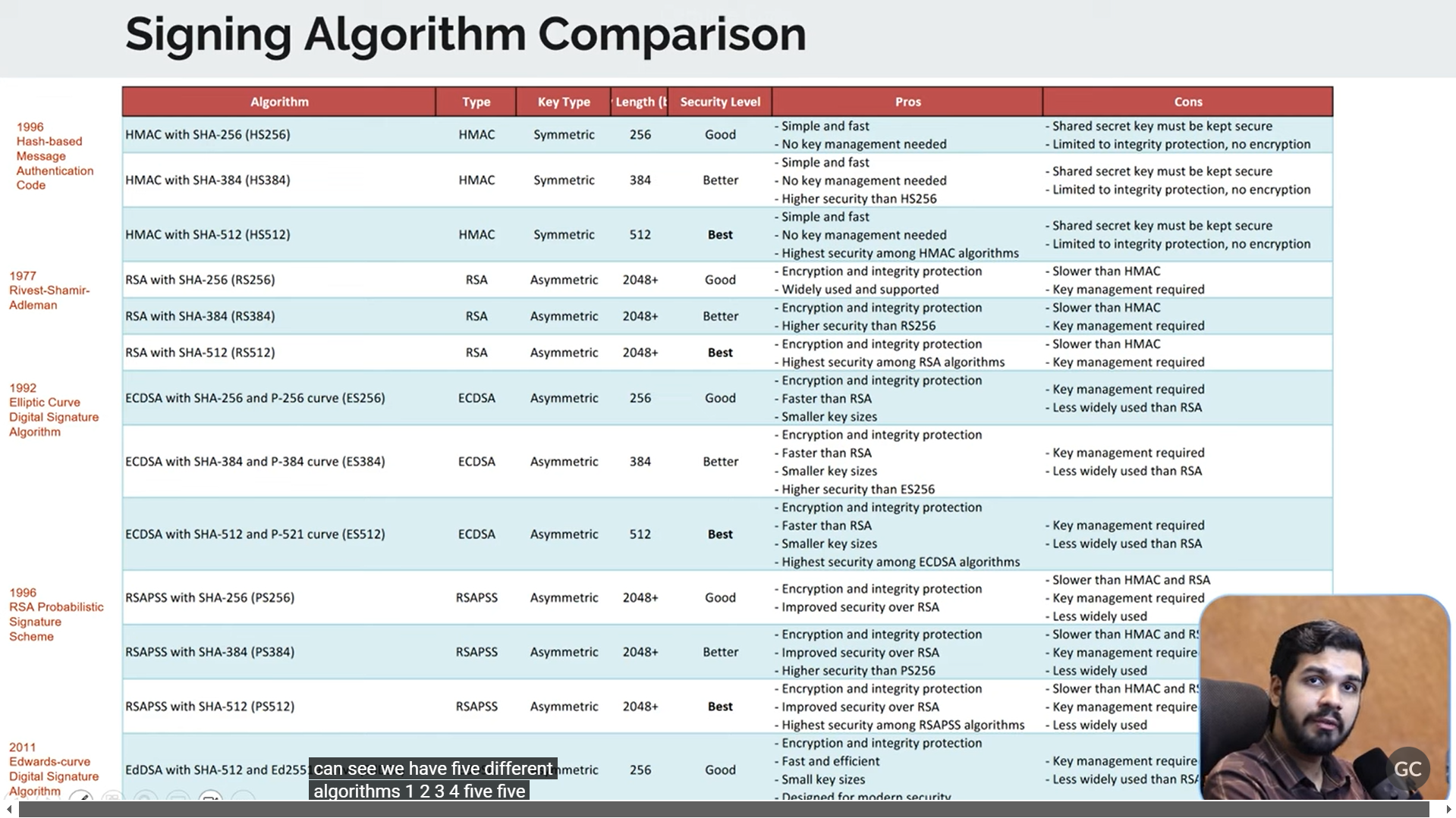

1. UsernamePasswordAuthenticationToken

What Is It?
- UsernamePasswordAuthenticationToken is a class in Spring Security that represents an authentication request or an authenticated principal once the request has been processed.
- It is used to store and pass along the username and password during authentication, and later to hold the user's authorities (roles/permissions) if authentication is successful.

When Is It Used?
- Before authentication:
You create an instance with the username and password provided by the user.
Example:
java
CopyEdit
Authentication authRequest = new UsernamePasswordAuthenticationToken(username, password);
- After successful authentication:
The authentication provider creates a new instance that includes the user's granted authorities.
java
CopyEdit
// After authentication:
Authentication authResult = new UsernamePasswordAuthenticationToken(userDetails, null, userDetails.getAuthorities());

Key Methods & Functions
- Constructors:
  - UsernamePasswordAuthenticationToken(Object principal, Object credentials):
Creates a token with the provided username (principal) and password (credentials). This is typically unauthenticated.
  - UsernamePasswordAuthenticationToken(Object principal, Object credentials, Collection<? extends GrantedAuthority> authorities):
Used when the user is authenticated, including their granted authorities.
- Getters:
  - getPrincipal(): Returns the user information (often a UserDetails object or username).
  - getCredentials(): Returns the password or other credentials.
  - getAuthorities(): Returns the list of roles/permissions assigned to the user.

Real-World Example
When a user logs in, the authentication manager might do something like:
java
CopyEdit
// Before authentication:
UsernamePasswordAuthenticationToken authRequest =
new UsernamePasswordAuthenticationToken(username, password);

// The AuthenticationManager authenticates and returns an authenticated token:
Authentication authResult = authenticationManager.authenticate(authRequest);

// authResult now contains the principal, credentials (usually null for security), and authorities.

2. SecurityContextHolder

What Is It?
- SecurityContextHolder is a utility class provided by Spring Security that holds the security context for the current execution thread.
- The SecurityContext contains details about the currently authenticated user (if any) in the form of an Authentication object.

How Does It Work?
- It uses a ThreadLocal storage mechanism, meaning that it holds data that is specific to the current thread of execution (or request).
- During a request:
When a user is authenticated, the Authentication object is set into the SecurityContextHolder. This information is then available throughout the request processing.
- After processing:
Spring Security ensures that the security context is cleared to prevent potential leaks between threads.

Key Methods & Functions
- SecurityContextHolder.getContext()
Returns the current SecurityContext.
Example:
java
CopyEdit
Authentication auth = SecurityContextHolder.getContext().getAuthentication();
- SecurityContextHolder.getContext().setAuthentication(Authentication authentication)
Sets the current authentication object in the context.
java
CopyEdit
SecurityContextHolder.getContext().setAuthentication(authResult);
- Clearing the context:
Often, Spring Security automatically clears the context at the end of request processing.

Real-World Example
Inside a filter (such as a JWT filter), after validating a JWT, you might load user details and then:
java
CopyEdit
UsernamePasswordAuthenticationToken authToken =
new UsernamePasswordAuthenticationToken(userDetails, null, userDetails.getAuthorities());
SecurityContextHolder.getContext().setAuthentication(authToken);
This makes the authenticated user available for the rest of the processing (for example, in controllers or other filters).

3. doFilterInternal

What Is It?
- doFilterInternal is a method you override when you extend Spring Security's OncePerRequestFilter (or a similar filter base class).
- This method contains the logic to process the request (preprocessing, filtering, authentication, etc.) and then passes control to the rest of the filter chain.

When Is It Called?
- It is called once per request and is where you can examine the incoming HttpServletRequest and potentially modify the HttpServletResponse.

Key Characteristics
- Parameters:
  - HttpServletRequest request: Represents the incoming HTTP request.
  - HttpServletResponse response: Represents the outgoing HTTP response.
  - FilterChain chain: Represents the chain of filters that the request should pass through.
- Responsibilities:
  - Extracting information (e.g., JWT token) from the request.
  - Validating the request (authentication, authorization checks).
  - Optionally setting the security context (using SecurityContextHolder).
  - Passing control to the next element in the chain by calling chain.doFilter(request, response).

Example Code in a Filter
java
CopyEdit
public class JwtFilter extends OncePerRequestFilter {
@Override
protected void doFilterInternal(HttpServletRequest request,
HttpServletResponse response,
FilterChain filterChain)
throws ServletException, IOException {
// 1. Extract token from the request header (if exists)
String authHeader = request.getHeader("Authorization");
if (authHeader != null && authHeader.startsWith("Bearer ")) {
String token = authHeader.substring(7);
// Validate token and extract username (pseudo-code)
String username = jwtService.extractUserName(token);
if (username != null && SecurityContextHolder.getContext().getAuthentication() == null) {
UserDetails userDetails = userDetailsService.loadUserByUsername(username);
if (jwtService.validateToken(token, userDetails)) {
UsernamePasswordAuthenticationToken authToken =
new UsernamePasswordAuthenticationToken(userDetails, null, userDetails.getAuthorities());
authToken.setDetails(new WebAuthenticationDetailsSource().buildDetails(request));
// Set the authentication in the Security Context
SecurityContextHolder.getContext().setAuthentication(authToken);
}
}
}
// Pass the request and response to the next filter in the chain
filterChain.doFilter(request, response);
}
}
- Before chain.doFilter: You perform authentication and set the security context.
- After chain.doFilter: The request has been processed further (or the response may be modified).

4. HttpServletResponse

What Is It?
- HttpServletResponse is an interface from the Java Servlet API that represents the HTTP response that the server sends back to the client.
- It is used to set the response’s status, headers, cookies, and the response body.

Key Methods & Functions
- Setting the HTTP Status Code
  - setStatus(int sc): Sets the HTTP status code (e.g., 200 OK, 404 Not Found).
  - sendError(int sc, String msg): Sends an error response with the given status code and error message.
  - sendError(int sc): Sends an error response with just the status code.
- Managing Response Headers
  - void setHeader(String name, String value): Sets a response header with the given name and value.
  - void addHeader(String name, String value): Adds a header value for the specified header name.
  - Example:
java
CopyEdit
response.setHeader("Content-Type", "application/json");
- Writing Content to the Response
  - PrintWriter getWriter(): Returns a PrintWriter that can be used to send character text to the client.
  - ServletOutputStream getOutputStream(): Returns a binary output stream to write binary data.
  - Example:
java
CopyEdit
PrintWriter out = response.getWriter();
out.write("{\"message\": \"Success\"}");
- Redirecting the Client
  - sendRedirect(String location): Redirects the client to a new URL.
- Managing Cookies and Buffering
  - addCookie(Cookie cookie): Adds a cookie to the response.
  - flushBuffer(): Forces any content in the buffer to be written to the client.

Real-World Example in a REST Endpoint
After processing a request (e.g., successful login or error handling), you might do:
java
CopyEdit
// In a controller or filter:
response.setContentType("application/json");
response.setStatus(HttpServletResponse.SC_OK);
PrintWriter writer = response.getWriter();
writer.write("{\"message\": \"Login successful\"}");
writer.flush();
- Content-Type is set to inform the client about the data type.
- Status Code is set to 200 (OK).
- The response body is written and flushed.

Putting It All Together: A Real-World Flow
Imagine a scenario where a user sends a request with a JWT token for authentication:
- The Filter (doFilterInternal) Intercepts the Request:
  - It uses HttpServletRequest to get headers, particularly the Authorization header.
  - It extracts the token and validates it.
  - If valid, it creates a UsernamePasswordAuthenticationToken with user details.
  - It then sets the authentication in the SecurityContextHolder so that downstream code knows the user is authenticated.
- The Filter Passes the Request On:
  - Calling filterChain.doFilter(request, response) sends the request further down the chain to the appropriate servlet or controller.
- The Servlet/Controller Uses HttpServletResponse:
  - After processing the request (for example, returning data or handling an error), the servlet or filter writes the response using HttpServletResponse (e.g., setting headers, status codes, and response content).

Summary
- UsernamePasswordAuthenticationToken:
  - Represents an authentication request or the authenticated user.
  - Holds username, password, and authorities.
- SecurityContextHolder:
  - Stores the current security context (authentication details) on a per-thread basis.
  - Provides static access to get/set the authentication.
- doFilterInternal:
  - A method overridden in filters (like OncePerRequestFilter) that processes each HTTP request.
  - Responsible for pre-processing (authentication, logging) and then passing the request on.
- HttpServletResponse:
  - Represents the HTTP response.
  - Used to set status codes, headers, cookies, and write the response body.
Understanding these components from scratch will help you grasp how Spring Security and the Servlet API collaborate to process, authenticate, and respond to HTTP requests in a robust web application.

_________________________________________________________________________________

Let's break down three fundamental components of Java web development using Servlets: HttpServletRequest, FilterChain, and HttpServletResponse. These interfaces play key roles in processing HTTP requests and responses in Java web applications (including those built with Spring).

1. HttpServletRequest

What Is It?
- HttpServletRequest is an interface (from the Java Servlet API) that represents the client's request to the web server.
- It provides methods to access:
  - HTTP Headers
  - Request Parameters
  - Cookies
  - Session Data
  - Request Body
  - And more…

Common Methods & Their Functions
- Request URL, URI & Method
  - String getMethod(): Returns the HTTP method (e.g., GET, POST, PUT, DELETE).
  - String getRequestURI(): Returns the part of the URL after the host and port (e.g., /login).
  - StringBuffer getRequestURL(): Returns the full URL as a StringBuffer.
- Query Parameters & Form Data
  - String getParameter(String name): Retrieves the value of a query or form parameter.
  - Map<String, String[]> getParameterMap(): Returns all parameters in a Map.
  - Enumeration<String> getParameterNames(): Lists the names of all parameters.
- Headers
  - String getHeader(String name): Returns the value of a specific HTTP header.
  - Enumeration<String> getHeaderNames(): Provides all header names.
  - Example: To get the Authorization header:
java
CopyEdit
String authHeader = request.getHeader("Authorization");
- Cookies
  - Cookie[] getCookies(): Returns an array of Cookie objects sent by the client.
  - Example:
java
CopyEdit
Cookie[] cookies = request.getCookies();
if (cookies != null) {
for (Cookie cookie : cookies) {
System.out.println(cookie.getName() + "=" + cookie.getValue());
}
}
- Session Management
  - HttpSession getSession(): Returns the current session associated with this request (or creates one if it doesn’t exist).
  - HttpSession getSession(boolean create): If create is false and no session exists, returns null.
- Request Body
  - BufferedReader getReader(): Reads the body of the request (useful for JSON or XML payloads).
  - ServletInputStream getInputStream(): Reads binary data from the request body.

Real-World Example
Imagine a login form submission:
- A user submits their username and password via a POST request.
- In your servlet or filter, you might access these like so:
java
CopyEdit
String username = request.getParameter("username");
String password = request.getParameter("password");

2. FilterChain

What Is It?
- FilterChain is an interface used within the Java Servlet Filter API.
- A Filter is a component that can preprocess requests and/or postprocess responses.
- FilterChain allows you to pass the request and response to the next filter or ultimately to the target servlet/resource.

Key Method
- void doFilter(ServletRequest request, ServletResponse response)
  - When you call chain.doFilter(request, response), you hand over control to the next filter in the chain. If there are no more filters, the request is forwarded to the target servlet (or resource).

How It Works in a Filter
- A filter's doFilter method is invoked for each request.
- The filter can perform actions before the request is processed (e.g., logging, authentication checks).
- The filter then calls chain.doFilter(request, response) to let the request continue.
- After the chain returns, the filter can perform post-processing on the response (e.g., modifying response headers).

Example of a Simple Filter
java
CopyEdit
import jakarta.servlet.Filter;
import jakarta.servlet.FilterChain;
import jakarta.servlet.FilterConfig;
import jakarta.servlet.ServletException;
import jakarta.servlet.ServletRequest;
import jakarta.servlet.ServletResponse;
import java.io.IOException;

public class LoggingFilter implements Filter {
@Override
public void doFilter(ServletRequest request, ServletResponse response, FilterChain chain)
throws IOException, ServletException {
System.out.println("Request received at " + System.currentTimeMillis());

// Continue with the next filter or target resource
chain.doFilter(request, response);

System.out.println("Response sent at " + System.currentTimeMillis());
}
}
- In this example: The filter logs the time before and after processing the request.

3. HttpServletResponse

What Is It?
- HttpServletResponse is an interface that represents the response the server sends back to the client.
- It is used to set response headers, HTTP status codes, cookies, and the response body (HTML, JSON, etc.).

Common Methods & Their Functions
- Setting Status Codes
  - void setStatus(int sc): Sets the HTTP status code (e.g., 200, 404, 500).
  - void sendError(int sc, String msg): Sends an error response with the specified status code and message.
- Managing Headers
  - void setHeader(String name, String value): Sets a header in the response.
  - void addHeader(String name, String value): Adds a header value to the response.
  - Example:
java
CopyEdit
response.setHeader("Content-Type", "application/json");
- Sending a Redirect
  - void sendRedirect(String location): Redirects the client to a different URL.
- Outputting Content
  - PrintWriter getWriter(): Returns a PrintWriter to write character text to the response.
  - ServletOutputStream getOutputStream(): Returns an output stream to write binary data.
  - Example:
java
CopyEdit
PrintWriter writer = response.getWriter();
writer.println("{\"message\": \"Success\"}");
- Cookies and Buffering
  - void addCookie(Cookie cookie): Adds a cookie to the response.
  - void setBufferSize(int size): Sets the buffer size for the response.
  - void flushBuffer(): Forces any content in the buffer to be written to the client.

Real-World Example
Imagine a REST API that returns JSON:
- After processing a request, you might set the content type and write JSON to the response:
java
CopyEdit
response.setContentType("application/json");
response.setStatus(HttpServletResponse.SC_OK);
PrintWriter out = response.getWriter();
out.write("{\"message\": \"User logged in successfully\"}");

Putting It All Together in a Filter (Real-World Use Case)
Imagine you have a JWT-based authentication filter:
- The filter intercepts each HTTP request.
- It uses HttpServletRequest to extract the JWT from the Authorization header.
- It validates the JWT.
- If valid, it sets authentication in the security context.
- It then calls chain.doFilter(request, response) to let the request proceed.
- Finally, HttpServletResponse can be used to set any necessary response headers (like caching rules or CORS settings).
Example (Simplified):
java
CopyEdit
public class JwtAuthenticationFilter extends OncePerRequestFilter {

@Override
protected void doFilterInternal(HttpServletRequest request,
HttpServletResponse response,
FilterChain filterChain)
throws ServletException, IOException {
// 1. Get the token from the Authorization header
String authHeader = request.getHeader("Authorization");
if (authHeader != null && authHeader.startsWith("Bearer ")) {
String token = authHeader.substring(7);
// Validate token (pseudo-code)
boolean validToken = validateToken(token);
if (!validToken) {
// If invalid, send error response
response.sendError(HttpServletResponse.SC_UNAUTHORIZED, "Invalid Token");
return;
}
// (Optional) Set authentication in SecurityContext here...
}

// 2. Continue the filter chain (passing the request and response)
filterChain.doFilter(request, response);
}

private boolean validateToken(String token) {
// Token validation logic goes here...
return true;
}
}
- HttpServletRequest: Used to read headers (extract JWT).
- FilterChain: Passes the request/response to the next element in the chain.
- HttpServletResponse: Used to send an error response if validation fails.

Summary
- HttpServletRequest
  - Role: Represents the incoming client request.
  - Key Uses: Read headers, parameters, body, cookies, etc.
- FilterChain
  - Role: Manages the order in which filters and ultimately the target servlet process a request.
  - Key Uses: Call chain.doFilter() to continue processing.
- HttpServletResponse
  - Role: Represents the outgoing server response.
  - Key Uses: Set status codes, headers, write output (text/HTML/JSON), and manage cookies.
Understanding these components is essential for developing robust, scalable, and secure web applications using the Java Servlet API (and frameworks like Spring). They work together to handle every step of processing an HTTP request—from receiving input to sending back a response.

